**EMPLOYMENT AGREEMENT**

*This agreement lays down the terms of employment, agreed upon by the employer and employee. Whether stated explicitly in the agreement or not, both the employee and the employer have the duty of mutual confidence and trust, and to make only lawful and reasonable demands on each other.*

__________________________________________________________

This EMPLOYMENT AGREEMENT (Hereinafter, the “Agreement”)is entered into on this ___ day of , 2024.

**BY AND BETWEEN**

OZRIT AI SOLUTIONS PVT LTD having its registered office at 303 A Block, The Platina , Kothaguda road , Gachibowli , Hyderabad, Telangana-500032., (hereinafter referred to as the “Company” or “Employer”, which expression shall, unless repugnant to the meaning

or context hereof, be deemed to include all permitted successors and assigns),

**AND**

Mr/Mrs. _______________ Son/Daughter of ___________ aged _____years and residing at__________________________________________________ (hereinafter referred to as the "Employee", which expression shall, unless repugnant to the meaning or context hereof, be deemed to include all permitted successors and assigns).

**WHEREAS,** the parties hereto desire to enter into this Agreement to define and set forth the terms and conditions of the employment of the Employee by the Company;

**NOW, THEREFORE,** in consideration of the mutual covenants and agreements set forth below, it is hereby covenanted and agreed by the Company and the Employee as follows:

# Interpretation

In this agreement the following terms shall have the following meanings:

| a) **“Confidential Information”** | The office data and software’s is to be kept confidential and it should not be shared to any third parties |
| --- | --- |
| **b)“The Employment”** | The employment of the Employee by the Company in accordance with the terms of this agreement; |

**c)“Termination ”**  An employee may be suspended from work immediately if he/she has allegedly committed or is allegedly involved in any one of the following offences:

1. Assault/attempted assault.
2. Sleeping on duty
3. Negligent loss, driving, damage or misuse of company property.
4. Abuse of electronic/data facilities
5. Fighting
6. Riotous Behavior
7. Alcohol and drug offenses
8. Willful loss, damage or misuse of company property
9. Theft/Unauthorized possession of company property
10. Breach of Trust.
11. Offenses related to dishonesty.
12. Offenses related to Industrial Action.

m) Any act or omission which intentionally endangers the health or safety of others, or is likely to cause damage to Company property

n) Abusive or provocative language

1. Insubordination (if the situation shows signs of getting out of control)
2. Persistent refusal to obey instructions

In cases of suspension or termination of an employee, the company reserves the right to withhold the employee's final salary payment until all outstanding matters are resolved. Additionally, no salary or documents will be provided to the employee in such cases

# Term and Probation Period

a. It is understood and agreed that the first 60 days of employment shall constitute a probationary period (“**Probationary Period**”) during which period the Employer will give necessary training to the employee, and also the employer in its absolute discretion, terminate the Employee's employment, without assigning any reasons and without notice or cause. After successful completion of the Probationary Period the employee should work for a period of 1 (one) year. If an employee wishes to resign, they are required to submit the three months’ notice to the company and for the sales 45 days of notice Period or if the company wishes to terminate an employee, they will provide one

month of notice to the employee and 15 days notice to the Sales . If the employee breaks the agreement he/she has to pay 3 month’s salary as a compensation to the

company failing which action will be taken against the employee in the jurisdiction of the Hyderabad Courts.

# Performance of Duties

a. The Employee agrees that during the Employment Period, he/she shall devote his/her full business time to the business affairs of the Company and shall perform the duties assigned to him/her faithfully and efficiently, and shall endeavor, to the best of his/her abilities to achieve the goals and adhere to the parameters set by the Company.

# Obligations of the Employee

1. The Employee shall always ensure that his/her conduct is in accordance with all the rules, regulations and policies of the Company as notified from time to time.
2. The Employee shall not take up part-time or full-time employment or consultation with any other party business during the term of his/her employment with the Company.

# Amendment and Termination

b. In case the Employer terminates the employment with any cause, in which case the Employer has the right to Terminate without giving any prior notice and for such period the employee will not get any salary for the said period.

# Applicable Law and Jurisdiction

This Agreement shall be governed by and construed in accordance with the laws. Each party hereby irrevocably submits to the exclusive jurisdiction of the courts of Hyderabad, for the adjudication of any dispute hereunder or in connection herewith.

**IN WITNESS WHEREOF**, the Employee has hereunto set his hand, and the Company has caused these presents to be executed in its name and on its behalf, all as of the day and year first above written.

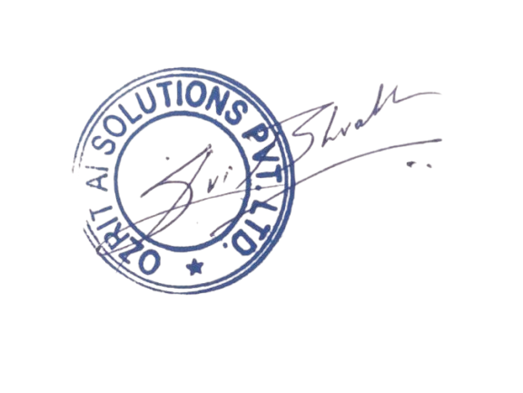

Name : _________________ Represented By : **Bharath Gupta**

Signature : _________________ Designation : **CEO**